Topic - Hollow square

# First written code-

# 

# There was an error : value required as left operand of assignment .

# Observation : the error may be because if we use “=” instead of “==” inside an “if” condition.

# Or

# The error may come due to “i=1” because “I” and “j” is a variable , but n is a constant ,so you cannot assign to a constant.

# Sol : don’t use “=” in “if” condition

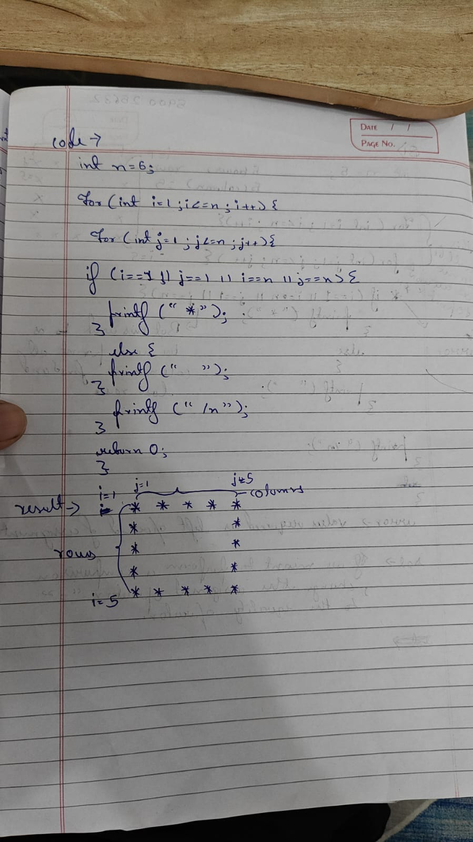

# If you don’t use “if else” condition and then want to print hole square

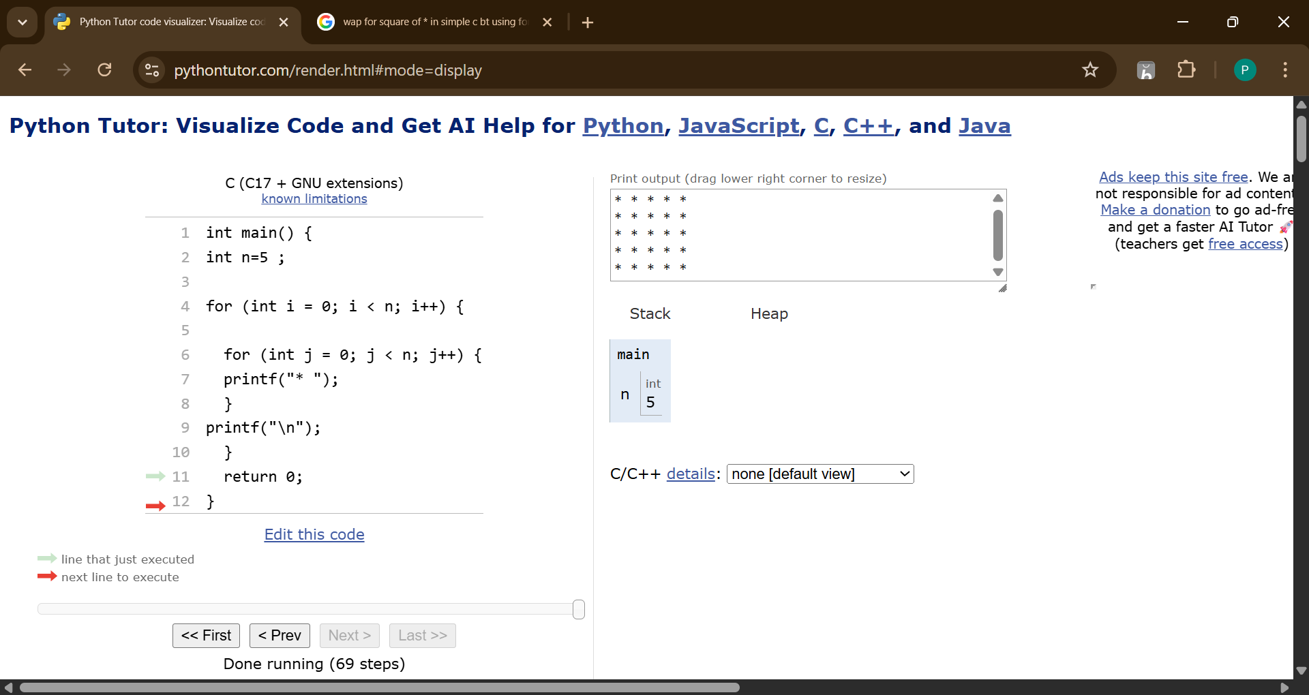

# But what’s the case when we want to print hollow square bigger than row =5 and column=5

# When we tried on python tutor it showed a error

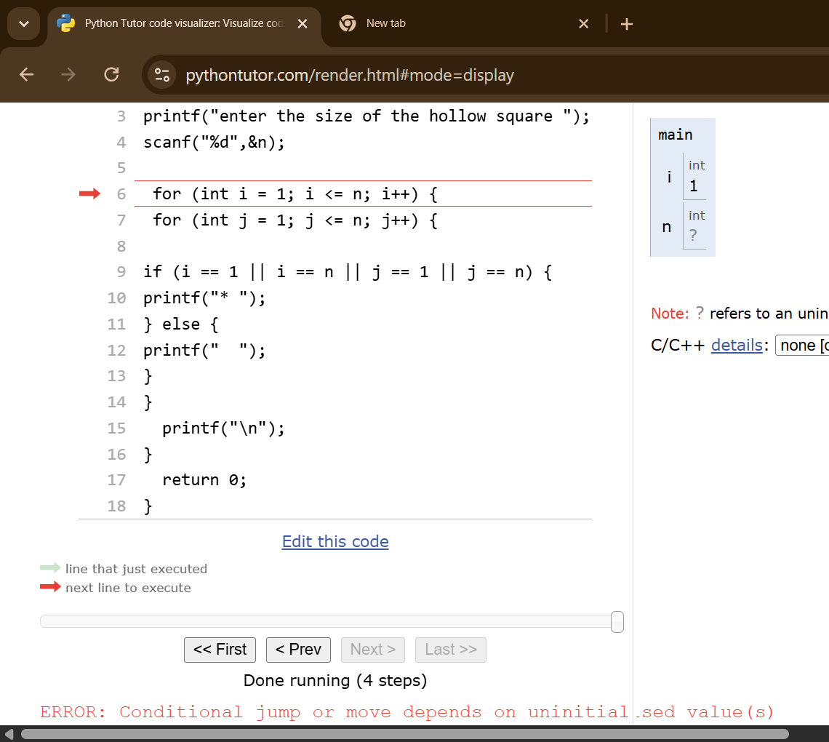

# Observation: it shows error of uninitialsed value

# Sol : put a value for “n” in the intiliaztion.

# But when I used it in a offline compiler :



 

 